EXP:7
Non-preemptive SJF (Experiment 7)
Note: Uses burst times 7, 4, 1.
CODE:
#include <stdio.h>
int main(void) {
int bt[] = {
7, 4, 1
}, p[] = {
1, 2, 3
}, i, j, t, wt[3] = {
0
}
;
for (i = 0; i < 2; i++)
for (j = i + 1; j < 3; j++)if (bt[i] > bt[j]) {
t = bt[i];
bt[i] = bt[j];
bt[j] = t;
t = p[i];
p[i] = p[j];
p[j] = t;
}
for (i = 1; i < 3; i++)
wt[i] = wt[i - 1] + bt[i - 1];
puts("Process Burst Waiting Turnaround");
for (i = 0; i < 3; i++)
printf("P%d %d %d %d\n", p[i], bt[i], wt[i], wt[i] + bt[i]);
return 0;
}
OUTPUT:
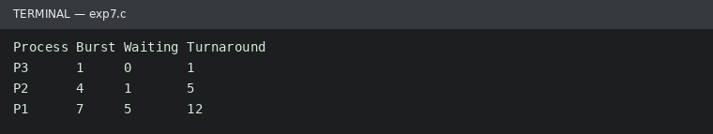
Run status: Ran successfully

